* Goal : Expose a web service that allows a user to (Render Document)
  + Pass in a document Id (file name)
  + Pass in data to pre-populate it with
  + Mark pre-populated fields as readonly
  + Embed QR Code at end of document
  + Set document password
* Overflow
  + Prepopulate Pdf (2)
    - Populate Fields
    - Mark Populated Fields as Read-only
    - Create UseCase for Prepopulate Pdf
  + Embed QR Code (2)
    - Create QR Code
    - Attach QR Code to pdf
* Work Items
  + Create Render Report Web Service (2)
    - Pass in a document Id (file name)
    - Pass in data to pre-populate it with
    - Mark pre-populated fields as readonly
    - Embed QR Code at end of document
    - Set document password
  + Password Protect Pdf using an ID number (2)
    - Aspose.Pdf .Net SDK for this
    - ~~Load File~~
    - Get Password
      * ID Number
    - Set Password on File
    - ~~Save File~~
  + Embed QR code into Pdf (3/2)
    - Aspose.Barcode cloud for this
      * I already have an abstraction to use
    - Write into PDF(2)
      * Load File
      * Create QR Code
        + Write string
        + Make sure it unique
      * Attach to File
      * Save File
    - ~~Read from PDF(1)~~
      * Load File
      * Extract QR Code
        + Verify QR Code
      * Extract string from QR Code
  + Pre-populate form (2)
    - ~~Aspose.Pdf .Net SDK for this~~
    - ~~Write to pdf & Mark as readonly~~
    - ~~Task~~
      * ~~Fetch / Load file~~
        + ~~File system~~
      * ~~Get Fields to Prepopulate~~
      * ~~Populate Fields~~
      * ~~Mark Fields as Read-only~~
      * ~~Save Prepopulated form~~
    - Caveats
      * Use f1040.pdf to populate and mark as read-only fields 76b and 76d to focus on single value cells.

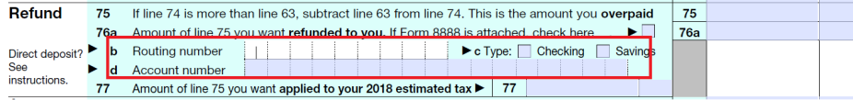

* + ~~Add swagger to project for demo~~
    - <https://petstore.swagger.io/?_ga=2.22299581.726126681.1529906503-2076919977.1529581832>
* Action Items
  + GitLab repository
  + SAHL to purchase Acrobat DC Pro
  + SAHL to purchase Aspose.Pdf .Net SDK
* Demo
  + Create document
    - Template
    - Data
    - QR Code Identifier (Guid)
  + Read barcode from document and ack return
    - Populated document as per above
    - Return Guid